**ELEMENTS OF POWER SYSTEMS**

**TUTORIAL 2**

**QUES 1.**

clc

clear all

A=[1,2,3;4,5,6;7,8,9] %created 3*3 matrix A

%a)

A(2:3,2:3) %gives row from 2 to 3 and column from 2 to 3

%b)

A(3,:)=[] %deletes third row and prints all columns

%c)

size(A) %find the size of the matrix

%d)

A(:) %prints all the elements of the array

%e)

A(end,:) %prints last row using end

%f)

Diag = diag(A) %gives diagonal elements of a matrix

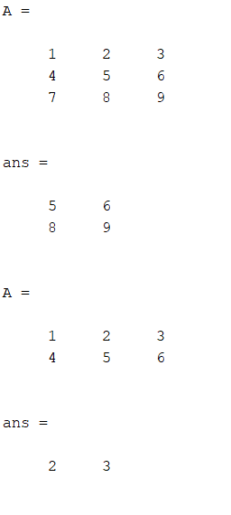

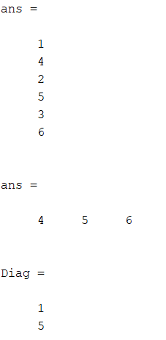

**QUES 2.**

clc

clear all

for i=1:100 %range of i

square(i)=i^2;

end

square

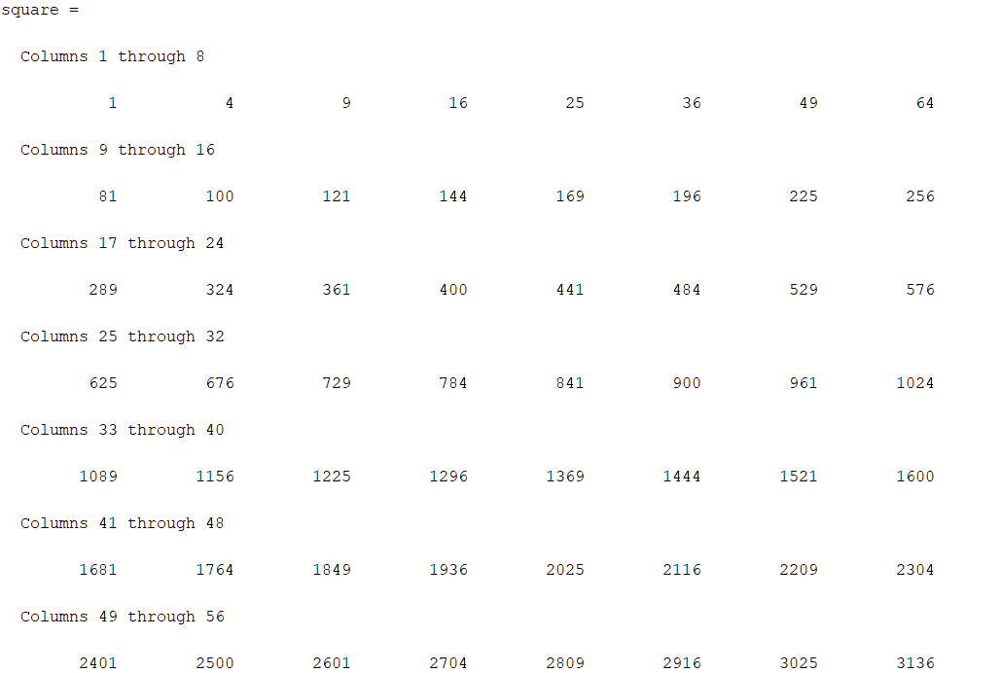

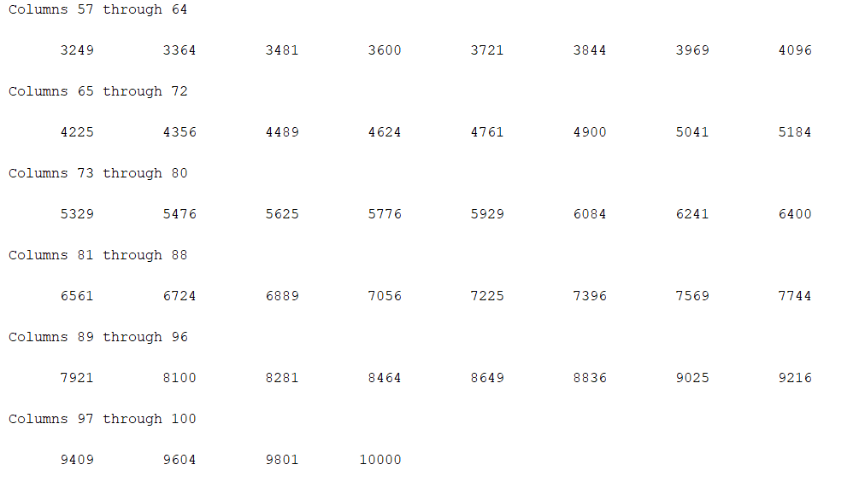

**QUES 3.**

clc

clear all

%v*y = i y is conductance

y=[0.15,-0.1,-0.05; -0.1,0.145,-0.025;-0.05,-0.025 ,0.075];

i=[5;0;2];

v=inv(y)*i; %basic formula

fprintf('Node voltages are \n v1=%3.3f v2=%3.2f v3=%3.1f \n',v);



**QUES 4.**

clc

clear all

%mesh analysis

%i=v*inv(r)

r =[4,-1,-3;-10,30,-5;-6,-1,13];

v=[1 0 0];

i=v*inv(r)

Irb=i(2)-i(1) %current through resistance rb

Power=10*i(1) %power supplied by 10V voltage source

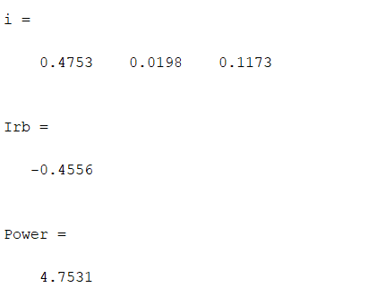

**QUES 5.**

clc

clear all

z1=3+4i;

z2=5+2i;

theta = pi/3;

z3=2*exp(i*theta);

z4=3+6i;

z5=1+2i;

z=(z1*z2*z3)/(z4*z5) %rectamgular form

magnitude = abs(z) %polar value

angle = angle(z)

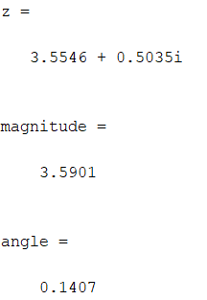

**QUES 6.**

clc

clear all

r=0;

res=1;

for i=2:20

for j=1:i

r=r+j^3;

end

res = res * r;

end

res

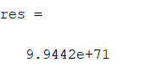

**QUES 7.**

clc

clear all

n= input('enter value of n : ');

for i=1:n %range of i

s(i)=sqrt(i); %squareroot

end

s

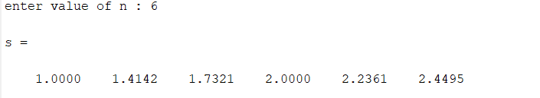

**QUES 8.**

clc

clear all

n= input('enter number of rows= ');

for i = 1:n

for j = 1:i

fprintf('*');

end

fprintf('\n');

end

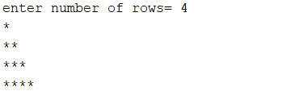

**QUES 9.**

clc

clear all

square=0

for i=2:20 %range of i

square = square + i^2; %sum of squares

end

square

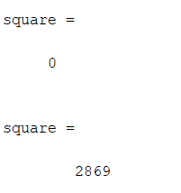

**QUES 10.**

clc

clear all

cube=0

for i=1:10 %range of i

cube = cube + i^3; %sum of cubes

end

cube

